Git is a free and open source distributed **version control system** designed to handle everything from small to very large projects with speed and efficiency.

Git is a distributed peer-peer version control system. Each node in the network is a peer, storing entire repositories which can also act as a multi-node distributed back-ups. There is no specific concept of a central server although nodes can be head-less or 'bare', taking on a role similar to the central server in centralised version control systems.

GitHub is a **web-based** Git repository **hosting service**, which offers all of the distributed revision control and source code management (SCM) functionality of Git as well as adding its own features.

Github provides access control and several collaboration features such as wikis, task management, and bug tracking and feature requests for every project.

You do **not need** GitHub to use Git.

GitHub (and any other local, remote or hosted system) can all be peers in the same distributed versioned repositories within a single project.

Github allows you to:

* Share your repositories with others.
* Access other user's repositories.
* Store remote copies of your repositories (github servers) as backup of your local copies.

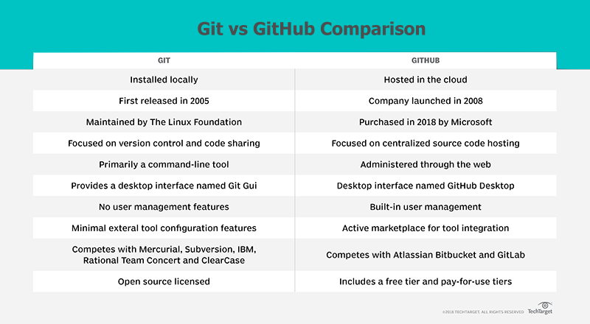

GitHub was developed by Chris Wanstrath, PJ Hyett, Tom Preston-Werner and Scott Chacon using Ruby on Rails, and started in February 2008. The company, GitHub, Inc., has existed since 2007 and is located in San Francisco.

It is mostly used for computer code.

It provides access control and several collaboration features such as bug tracking, feature requests, task management, and wikis for every project.

GitHub offers plans for both private repositories and free accounts which are commonly used to host open-source software projects. As of June 2018, GitHub reports having over 28 million users and 57 million repositories  (including 28 million public repositories), making it the largest host of source code in the world.

On June 4, 2018, Microsoft announced it had reached an agreement to acquire GitHub for US$7.5 billion.The purchase closed on October 26, 2018.

GitHub will continue to operate independently as a community, platform and business.

**Organizational structure**

GitHub, Inc. was originally a flat organization with no middle managers; in other words, "everyone is a manager" (self-management). Employees can choose to work on projects that interest them (open allocation). However, salaries are set by the chief executive..

In 2014, GitHub, Inc. introduced a layer of middle management.

**GitHub Marketplace service**

GitHub also provides some software as a service integrations for adding extra features to projects. Those services include:

Waffle.io: Project management for software teams. Automatically see pull requests, automated builds, reviews, and deployments across all of your repositories in GitHub.

Rollbar: Integrate with GitHub to provide real time debugging tools and full-stack exception reporting. It is compatible with all well used code languages, such as JavaScript, Python, .NET, Ruby, PHP, Node.js, Android, iOS, Go, Java, and C#.

Codebeat: For automated code analysis specialized in web and mobile developers. The supported languages for this software are: Elixir, Go, Java, Swift, JavaScript, Python, Ruby, Kotlin, Objective-C, and TypeScript.

Travis CI: To provide confidence for your apps while doing test and ship. Also gives full control over the build environment, to adapt it to the code. Supported languages: Go, Java, JavaScript, Objective-C, Python, PHP, Ruby, and Swift.

GitLocalize: Developed for teams that are translating their content from one point to another. GitLocalize automatically syncs with your repository so you can keep your workflow on GitHub. It also keeps you updated on what needs to be translated.

## Developed projects

* Atom, a free and open-source text and source code editor
* Electron, an open-source framework to use javascript-based websites as desktop applications.

Version control is independent of the kind of project / technology / framework you're working with:

* It works just as well for an HTML website as it does for a design project or an iPhone app
* It lets you work with any tool you like; it doesn't care what kind of text editor, graphics program, file manager or other tool you use

Also, don't confuse a VCS with a backup or a deployment system. You don't have to change or replace any other part of your tool chain when you start using version control.

A version control system records the changes you make to your project's files. This is what version control is about. It's really as simple as it sounds.